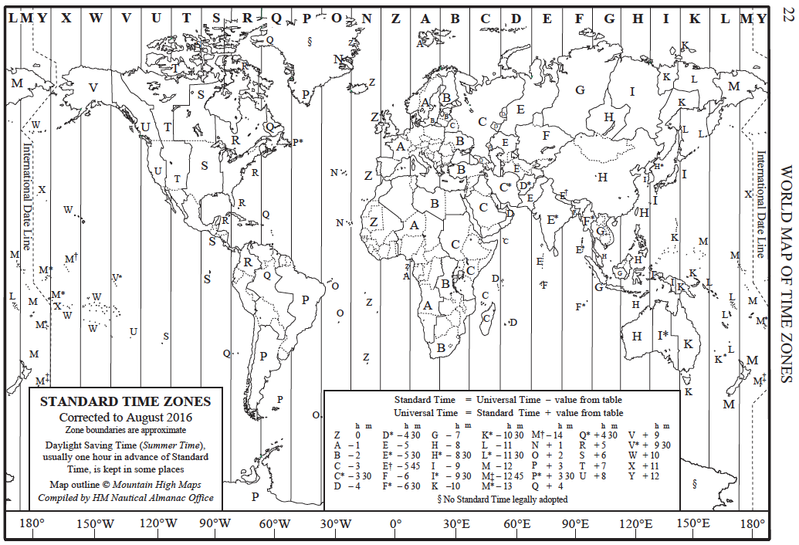

**QUESTION ONE**

(6 marks)

Using the time zone map, complete the following table to show the local time that you must initiate a phone call to a family member in PERTH so that you call them at 7.30pm PERTH time. You need to call at least once from each city that you visit during your round the world trip.

|  |  |  |
| --- | --- | --- |
| **City** | **Local time in city** | **Time in Perth** |
| Hanoi, Vietnam | 6:30 pm | 7:30 pm. |
| Calcutta, India | 5:00 pm | 7:30 pm. |
| Cairo, Egypt | 1:30 pm | 7:30 pm. |
| Rome, Italy | 12:30 pm | 7:30 pm. |
| Jacksonville, USA | 7:30 am | 7:30 pm. |
| Cusco, Peru | 7:30 am | 7:30 pm. |

**QUESTION TWO**

(12 marks)

Using your information from your home work, complete the following table showing the currency exchange for six of the countries that you will visit. Answers are approximate and may vary

|  |  |  |  |
| --- | --- | --- | --- |
| Country | Currency Abbreviation | Cost in AUD for 100 or 1000 (delete as appropriate) of the local currency. | AUD100 converts to how many of the local currency? |
| Vietnam | VND | 1 000 VND = 0.06 AUD | 1 698 080 VND |
| India | INR | 100 INR = 1.96 AUD | 5 109 INR |
| Egypt | EGP | 100 EGP = 7.68 AUD | 1 301 EGP |
| Italy | EUR | 100 EUR = 158.82 AUD | 62.97 EUR |
| USA | USD | 100 USD = 137.26 AUD | 72.84 USD |
| Peru | PEN | 100 PEN = 41.57 AUD | 240.54 PEN |

**QUESTION THREE**

For the flights between the six main cities, complete the following table:

Answers will vary and depend of flights chosen

(24 points)

|  |  |  |  |  |  |  |
| --- | --- | --- | --- | --- | --- | --- |
| Start city (give time zone) | End city  (give time zone) | Start time (give time zone) | End time (same time zone as start time zone) | Flight time (h:m) | Flight distance (km) | Average flight speed (km/h) |
| Perth GMT+8 | Hanoi, Vietnam |  |  | Approx. 6hr | 5 994 |  |
| Hanoi GMT+7 | Calcutta, India |  |  | Approx. 2hr | 1 813 |  |
| Calcutta GMT+5.30 | Cairo, Egypt |  |  | Approx. 5.5hr | 5 704 |  |
| Cairo GMT+2 | Rome, Italy |  |  | Approx. 2hr | 2 135 |  |
| Rome GMT+1 | Jacksonville, USA |  |  | Approx. 8hr | 8 137 |  |
| Jacksonville GMT-5 | Cusco, Peru |  |  | Approx. 5hr | 4 992 |  |
| Cusco GMT-5 | Perth, Australia |  |  | Approx. 14hr | 14 906 |  |